Evolution du TEB en fonction du RSB sur le canal AWGN

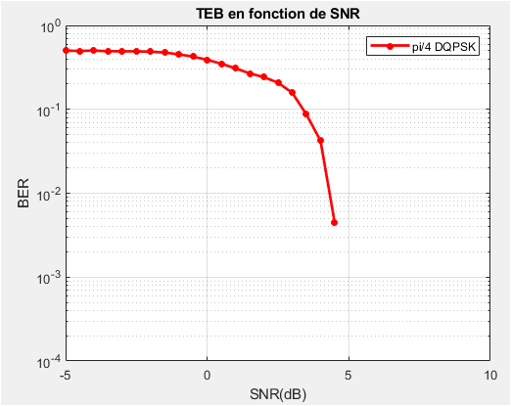

|  |  |  |  |  |  |  |  |  |  |  |
| --- | --- | --- | --- | --- | --- | --- | --- | --- | --- | --- |
| SNRdB | 0 | 0.5 | 1. | 1.5 | 2 | 2.5 | 3 | 3.5 | 4 | 5 |
| TEB | 0.3891 | 0.3495 | 0.3079 | 0.2679 | 0.2417 | 0.1578 | 0.1578 | 0.0873 | 0.0423 | 0 |